**Software Testing Assignment**

**Module – 5 Selenium IDE**

1. **What is Automation Testing?**

Automated testing is the application of software tools to automate a human-driven manual process of reviewing and validating a software product.

1. **Which Are The Browsers Supported By Selenium Ide?**

Browsers supported by Selenium IDE are Firefox and Chrome Browsers.

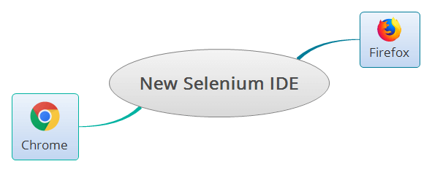

1. **What are the benefits of Automation Testing?**

**Benefits of Automation Testing :**

* Saving Costs.
* Faster Feedback Loop.
* Better Allocation of Resources.
* Guarantees Higher Accuracy.
* Increased Test Coverage.
* Detects bugs earlier.
* Test at Scale.
* Increasing Employee Satisfaction and Retention.

1. **What are the advantages of Selenium?**

**Advantages of Selenium for Automated Testing**

1. Language and Framework Support

2. Open Source Availability

3. Multi-Browser Support

4. Support Across Various Operations

5. Ease of Implementation

6. Reusability and Integrations

7. Flexibility

8. Parallel test execution and faster market launch

9. Less Hardware Usage

10. Easy to Learn and Use

1. **Why testers should opt for Selenium and not QTP?**

For beginners in automation testing, Selenium is generally recommended over QTP/UFT because it is free, open-source, and supports multiple programming languages. This makes it easier to learn and use Selenium, and it gives testers more flexibility in their choice of programming language.

|  |  |  |
| --- | --- | --- |
| **Features** | **Selenium** | **QTP** |
| **Flexibility** | Runs across all the browsers | Supports only Windows |
| **License** | Open-source | Licensed |
| **Environment** | Allows all additional plugins | Supports SAP, Oracle and includes no add-ons to the software |
| **Browser Area Accessibility** | Controls the visible area of the browser where the page is loaded | Controls the menu and toolbars of the browser and all other website toolkits with various formats |
| **Programming Language** | Supports mature Object-Oriented Languages like Java | Supports only VBScript. Thus, the Object-Oriented Approach to automation becomes challenging with QTP/UFT |